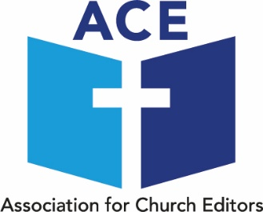

Annual Meeting
In the Chapel at Central Hall Westminster, Storey’s Gate,
London SW1H 9NH
Saturday 26th September 2026

Booking Form
Please send the completed form to:
Alan Rickards, 51 West Way, Holmes Chapel, Cheshire CW4 7DG or via
email: acetreasurer@aol.com by Saturday 12th September 2026 at the very latest

Name:

E-mail Address:
Church and Village/Town/City

Magazine name

I will be accompanied by the following guest(s):

Name(s):

I enclose a cheque payable to Association for Church Editors (£10 for first
person, with guests charged at £5 each) to help cover the costs of the day,
or,
I have paid by bank transfer to: ‘Association for Church Editors (ACE)’
Sort Code: 20 24 09; Account no. 50503142
(Please include AGM and your surname as the reference.)

Teas and coffees will be provided. Unfortunately no food is allowed in the Chapel,
but there is a café on site where food can be purchased and consumed or
there are cafés nearby, including Pret A Manger along Tothill Street.

Travel
There are two underground stations within five minutes walk of the venue – Westminster, which is served by the Jubilee, District and Circle lines and St. James’s Park, served by the District and Circle lines. Central Hall is also within reasonable walking distance of Victoria, Charing Cross and Waterloo mainline stations.

